VEDA WMTS Tools for ArcGIS Pro

# Overview

The VEDA WMTS Tools provide a streamlined workflow to access NASA VEDA STAC data through WMTS (Web Map Tile Service) connections in ArcGIS Pro. This toolbox generates properly formatted WMTS URLs from VEDA's STAC catalog and organizes them in a table for easy access.

# Current Issue with creating a WMTS Server Connection within ArcGIS Pro

While there is a direct option to pass specific parameters within the ArcGIS, there is a direct conflict with adding the bbox parameter which inhibits a successful STAC connection. Therefore, alternative modes must be investigated to overcome this limitation. This is proposed through the use of an ArcGIS Toolbox that can read from VEDA STAC and create Raster API-derived WMTS links.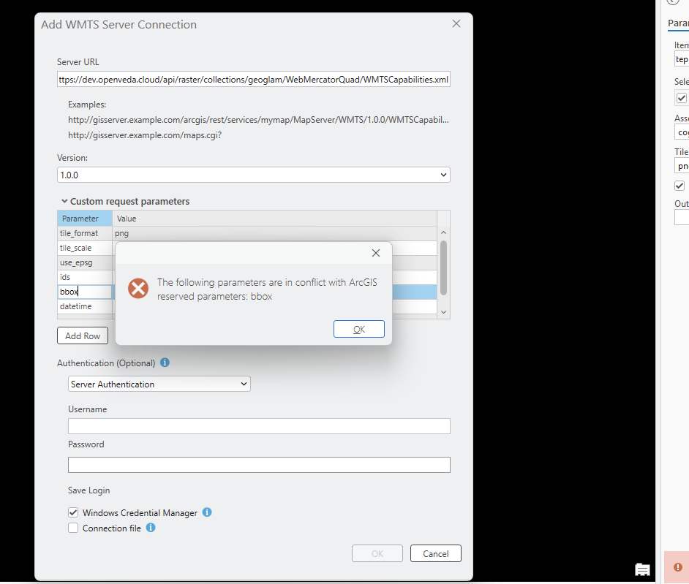

# Toolbox Workflow

## Step 1: Browse STAC Collections

* Purpose: Select a collection from VEDA's STAC catalog
* Input: STAC API URL (Development or Production)
* Process: Tool queries the API and displays all available collections
* Output: Table containing selected collection information

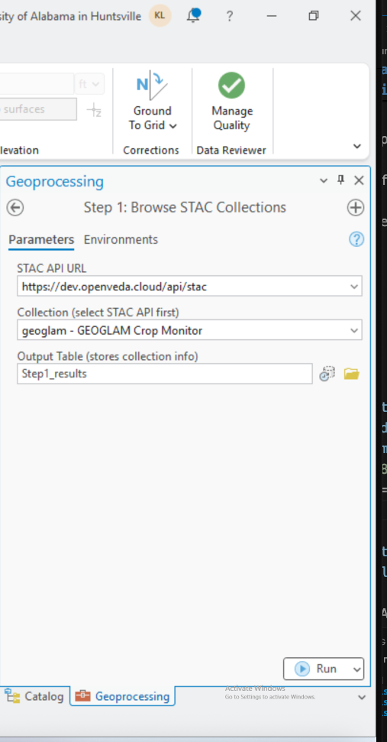

## Step 2: Browse Collection Items

* Purpose: Find specific items (datasets) within the selected collection
* Input: Collection table from Step 1
* Process: Tool queries items and extracts metadata (datetime, bbox, assets)
* Output: Table containing item details for all available datasets

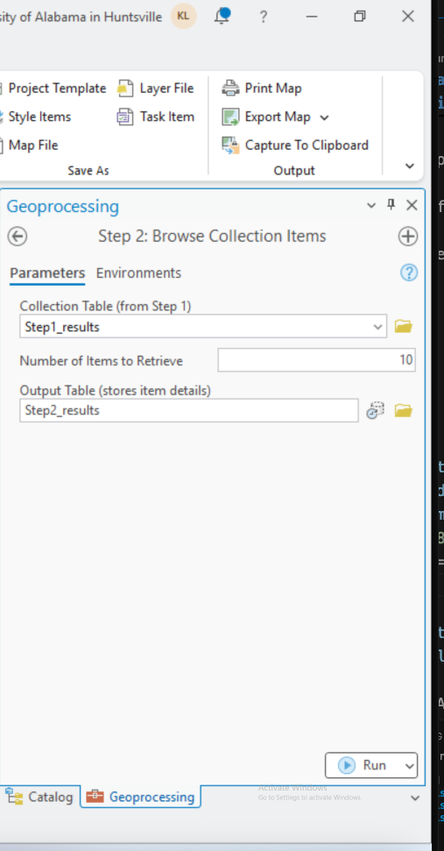

## Step 3: Create WMTS Connection

* Purpose: Generate WMTS Capabilities URLs for selected items
* Input: Items table from Step 2, asset type, tile format
* Process: Tool builds properly formatted WMTS URLs with all parameters
* Output: Table with WMTS URLs that appears in Contents pane under Standalone Tables

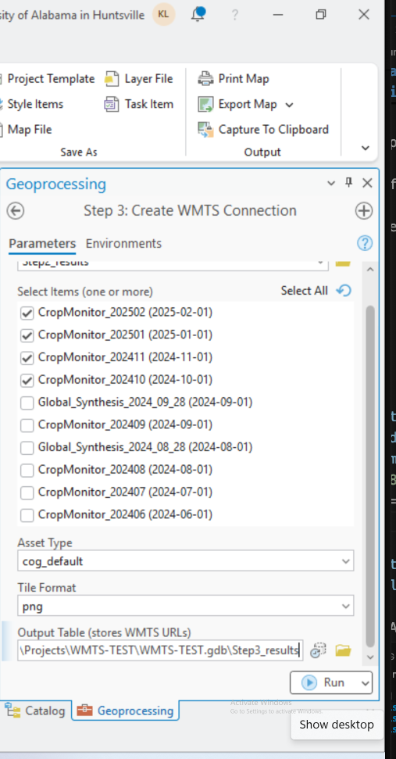

________________________________________________________________________________

# After running the toolbox (Steps 1-3), follow these instructions to add WMTS layers to your map:

## Part A: Accessing the WMTS URLs

1. Locate the Table in Contents Pane

- Look in the Contents pane (left side of ArcGIS Pro)

- Scroll down to the "Standalone Tables" section

- Find your output table (e.g., wmts_urls_table)

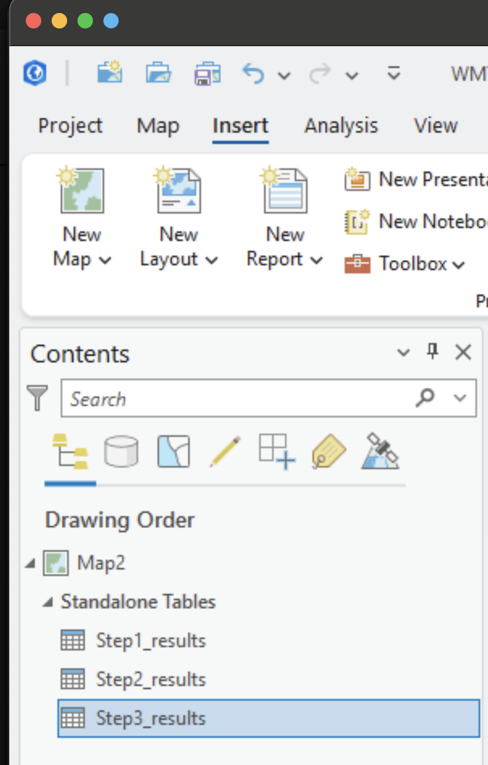

1. Open the Table

- Right-click on the table name

- Select "Open" from the context menu

- The attribute table opens showing all fields

1. Copy a WMTS URL

- Locate the wmts_url column in the table

- Click on a cell in the wmts_url column to select it

- The full URL should be highlighted

- Right-click the selected cell

- Choose "Copy" from the menu

- Alternatively, press Ctrl+C (Windows) or Cmd+C (Mac)

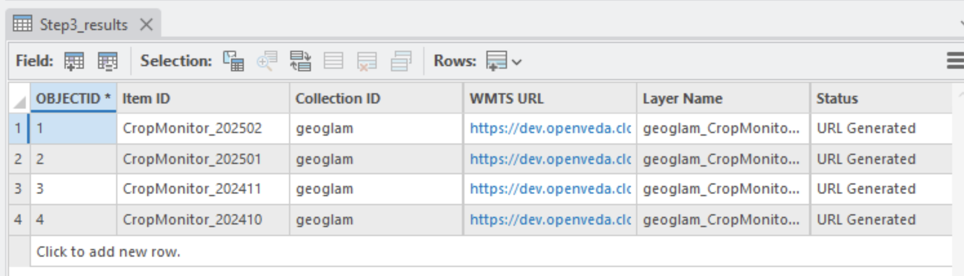

## Part B: Creating the WMTS Server Connection

1. Open the Add WMTS Server Dialog

- Switch to the Catalog pane (right side of ArcGIS Pro)

- Expand the "Servers" folder

- Right-click on "Servers"

- Select "New WMTS Server" from the menu

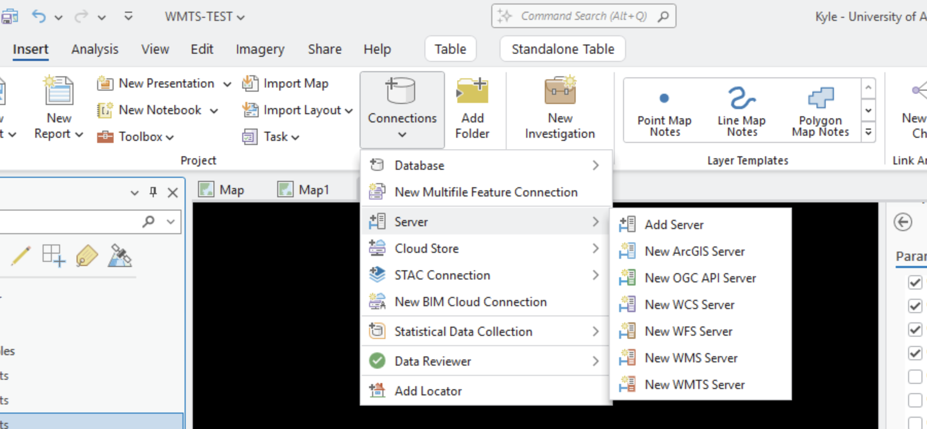

1. Paste the WMTS URL

- A dialog box titled "Add WMTS Server Connection" appears

- In the "Server URL" field, paste the WMTS URL you copied

- The URL should look like:

https://dev.openveda.cloud/api/raster/collections/geoglam/WebMercatorQuad/WMTSCapabilities.xml?tile_format=png&tile_scale=1&use_epsg=true&ids=CropMonitor_202502&bbox=-180.0,-90.0,180.0,90.0&datetime=2025-02-01T00:00:00Z&assets=cog_default

- Optionally, give the connection a descriptive name in the "Name" field

- Click "OK"

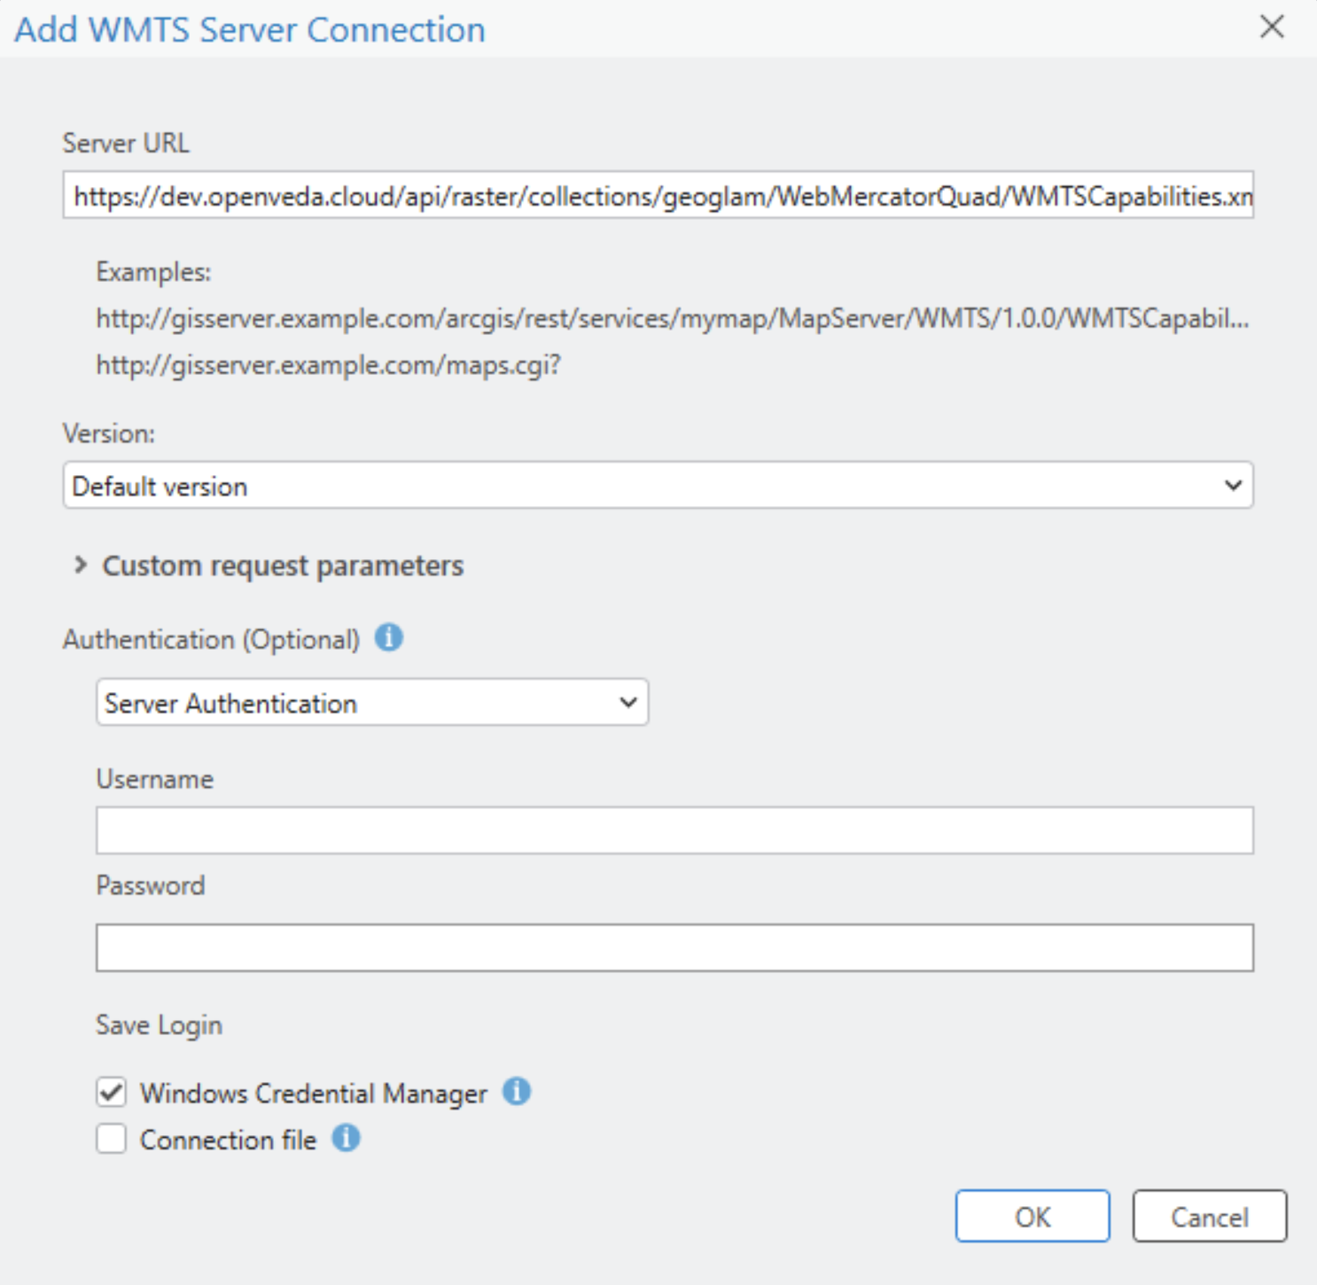

1. Wait for Connection

- ArcGIS Pro will connect to the WMTS server

- This may take a few seconds

- A new server connection (.wmts file) appears under "Servers" in Catalog

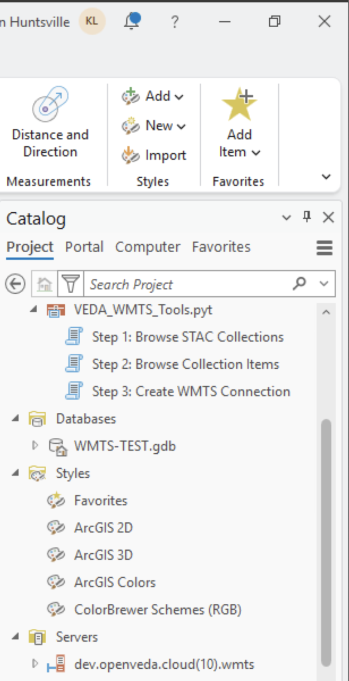

## Part C: Adding Layers to Your Map

1. Expand the WMTS Connection

- In the Catalog pane, locate the new WMTS server connection

- It will be under "Servers" with a globe icon

- Click the arrow next to the connection to expand it

1. Browse Available Layers

- You'll see one or more layers listed under the connection

- These represent the actual data layers available

- Hover over layer names to see details

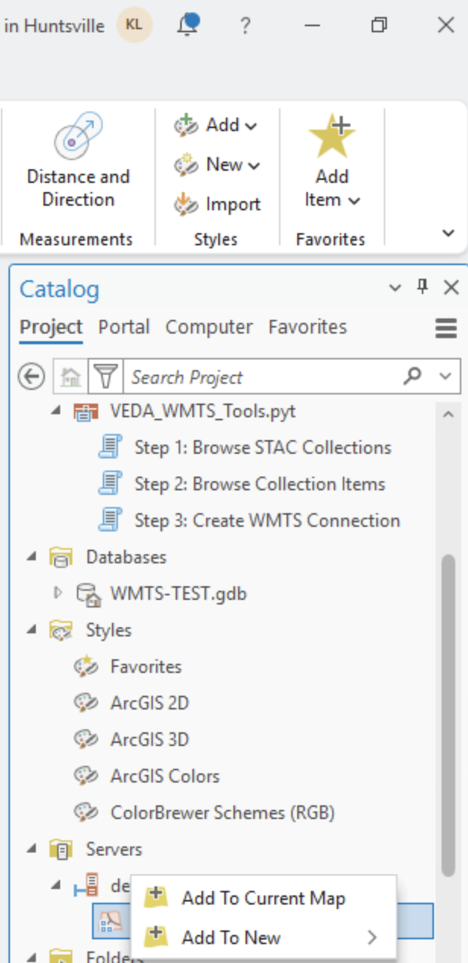

1. Add Layer to Map

- Drag and drop a layer from the Catalog pane to your map

- OR Right-click the layer → "Add to Current Map"

- The layer appears in the Contents pane under your map layers

- The data begins loading and rendering on your map

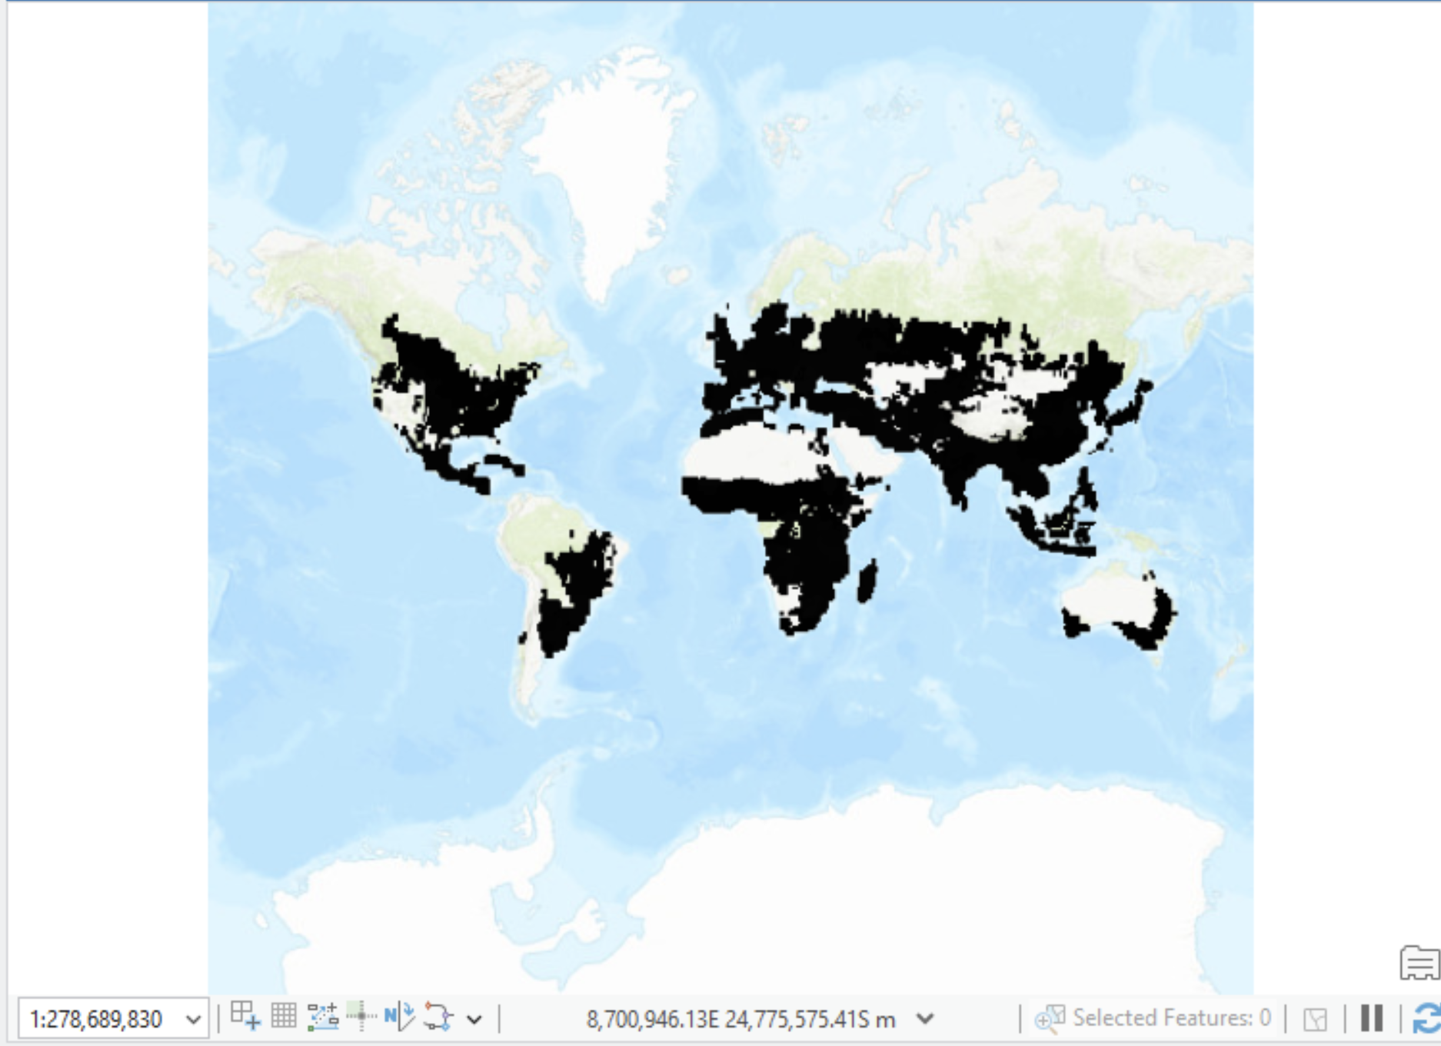

________________________________________________________________________________

# Understanding the WMTS URL Components

Each WMTS URL contains several important parameters:

https://dev.openveda.cloud/api/raster/collections/{collection}/  
WebMercatorQuad/WMTSCapabilities.xml?  
tile_format=png&  
tile_scale=1&  
use_epsg=true&  
ids={item_id}&  
bbox={minx,miny,maxx,maxy}&  
datetime={timestamp}&  
assets={asset_type}

* collection: STAC collection identifier (e.g., geoglam)
* item_id: Specific dataset identifier (e.g., CropMonitor_202502)
* tile_format: Image format - png (quality) or jpg (speed)
* bbox: Bounding box coordinates for the data extent
* datetime: Temporal information for the dataset
* assets: Asset type, typically cog_default

# Issues to Fix in the Future:

1. Returning colormaps – currently the data doesn’t appear to allow for color pallettes to be added in the “Properties” section.